If growth in world demand is the key, why are US crop exports not growing?
A central element of the effort to convince US crop farmers that the completion of the current round of World Trade Organization (WTO) is good for them is the promise that by providing crop farmers with a level playing field it will enable them to increase their share of export markets. Increasing exports of seeds and grains has been a goal of US farm policy since the 1985 Farm Bill when loan rates were lowered.
The 1996 Farm Bill with its decoupled market oriented approach was designed to allow US crop producers to increase their exports by allowing the price to drop to the world price. And by eliminating set-asides, the legislation was designed to force our export competitors to cut back on their acreage and thus production, or at least in the case of Brazil slow down their acreage expansion. Despite these policy changes, aggregate US crop exports have been flat to down for the last quarter century.
In some ways the current focus has changed from taking business from our competitors to using trade liberalization to grow the market. One of the implications of this argument is that world export markets for grains and seeds have been stable over the recent past.
To put some perspective on the issue of trade liberalization and who may benefit from export market growth, let’s look at some data that we recently compiled at the request of Senator Kent Conrad’s (ND) office. For that study we looked at total exports of eight grains (wheat, corn, rice, sorghum, oats, rye, barley, and millet) and seven oilseeds (soybeans, peanuts, cottonseed, rapeseed/canola, sunflower, copra, and palm kernel) over the last 25 years (1979-2004). We paid particular attention to the exports of our developing country competitors compared to those of the US. The results were enlightening and say something about who may capture future export growth.
Over the 25 year period, world exports for the 15 crops (the grains and seeds of interest to the US and their major substitutes) increased from 225 thousand tonnes (metric tons) to 313 thousand tonnes, a gain of 88 thousand tonnes (figure 1). At the same time, US exports fell by 23 thousand tonnes from 137 thousand tonnes in 1979 (the peak of US exports) to 114 thousand tonnes for the 2004 crop year.
Even under current trading policies, our developing country export competitors (Argentina, Brazil, China, India, Pakistan, Thailand, and Vietnam) have substantially increased their level of exports from 19 thousand tonnes in 1979 to 90 thousand tonnes in 2004. The 71 thousand tonne increase of these developing competitors has nearly matched the world 15 crop export increase of 88 thousand tonnes. The exports of our developing country export competitors has risen at a faster rate since the adoption of the export oriented 1996 Farm Bill than it did in the prior 15 years.
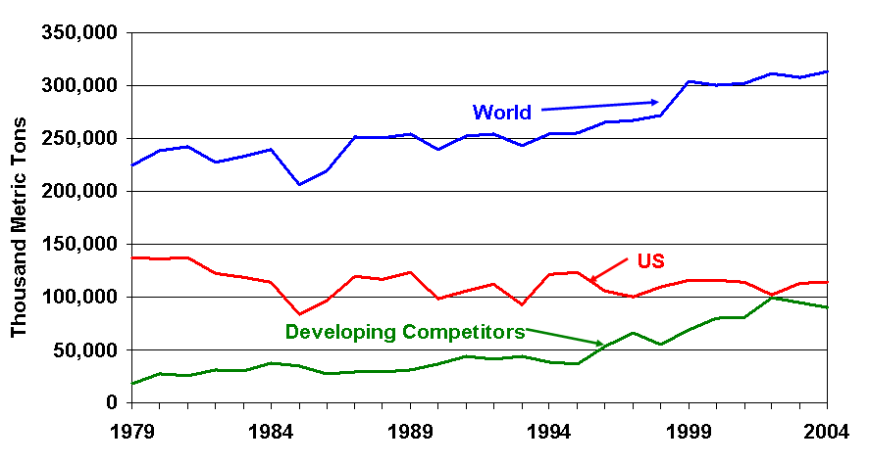
Figure 1. Exports of 15 seeds and grains (wheat, corn, rice, sorghum, oats, rye, barley, millet, soybeans, peanuts, cottonseed, rapeseed/canola, sunflower, copra, and palm kernel) for the world, the US and seven developing country competitors (Argentina, Brazil, China, India, Pakistan, Thailand, and Vietnam) for the crop years 1979-2004. Source: USDA, PS&D.

Over the last 25 years the 15 crop exports increased by 39% while US exports continued to decline. In our minds the numbers behind this trend and the others we see in figure 1 cast doubt on the optimism that the current round of trade negotiations will bring about an era of export led prosperity for US crop farmers. The numbers also cast doubt on a strategy that asserts that by using trade liberalization to grow the export market, both the US and our export competitors can increase their exports.
The trends in figure 1 are consistent with the assertion that the US is the world’s residual supplier of seeds and grains. As productivity and land resources increase in countries around the world, they are able to float their surplus out of the port and into international markets with the US capturing what is left. From our perspective it is difficult to see how any of the mechanisms being talked about in WTO negotiations will change that long-term market dynamic, at least for the current generation of farmers.

Daryll E. Ray holds the Blasingame Chair of Excellence in Agricultural Policy, Institute of Agriculture, University of Tennessee, and is the Director of UT’s Agricultural Policy Analysis Center (APAC). (865) 974-7407; Fax: (865) 974-7298; dray@utk.edu; http://www.agpolicy.org. Daryll Ray’s column is written with the research and assistance of Harwood D. Schaffer, Research Associate with APAC.

Reproduction Permission Granted with:
1) Full attribution to Daryll E. Ray and the Agricultural Policy Analysis Center, University of Tennessee, Knoxville, TN;
2) An email sent to hdschaffer@utk.edu indicating how often you intend on running Dr. Ray’s column and your total circulation. Also, please send one copy of the first issue with Dr. Ray’s column in it to Harwood Schaffer, Agricultural Policy Analysis Center, 310 Morgan Hall, Knoxville, TN 37996-4519.

Figure 1

