Touring the black soil area of China
As we planned our trip to China one of the places we wanted to visit was Heilongjiang province—the largest soybean growing area in the country—because of China’s growing role as a soybean importer in international markets. Our hosts at the Chinese Academy of Sciences (CAS) in Beijing were kind enough to link us up with one of their colleagues, Dr. Yanli Xu, Professor and Vice Director of the Northeast Institute of Geography and Agroecology (NEIGAE), CAS, Crop Physiology and Ecology Laboratory in Harbin, the capital of Heilongjiang province. Assistant Professor Chunjie Li joined Dr. Xu in helping us learn more about agriculture, in general, and soybean production, in particular, in Heilongjiang..
The latitude of Heilongjiang province corresponds roughly to that of North and South Dakota. Harbin is on the same latitude as the state line between the Dakotas and hosts a month long Ice Festival beginning on January 5 of each year. The capital is also home to numerous universities, two of which are agriculturally related: Northeast Agricultural University and Northeast Forestry University.
After spending a day seeing some of the summer sights in Harbin, we headed out into the countryside in a car with Professor C. Li and a driver. We were headed for the Hailun Experiment Station which is 120 road miles north of Harbin and 150 miles as the crow flies—the road mileage is longer)from the Amur River and the Russian Far East.
The ride north gave us a chance to look at the agriculture taking place outside our window and compare it with what we saw on the train headed south from Beijing toward the Yucheng Comprehensive Experiment Station. Again, the fields were large, but given the difference in latitude, the summer crops were just emerging from the rich black soil. Were later to learn that this rich black soil is the same Clarion-Webster soil so familiar to farmers in large parts of Iowa, Illinois, and Southern Wisconsin.
While there were large fields, small fields were again shoe horned into places that would not be farmed in the US. We were surprised to see paddies of rice growing alongside fields of corn, soybean, and spring wheat. The rice paddies were often tucked in against larger fields along waterways, and were often terraced even in this relatively level land. The agriculture we saw could be characterized as peasant production.

Looking out toward the horizon, villages dotted the landscape, surrounded by their farmland. Adjacent to the villages were a large number of stacks of corn fodder. The fodder was neatly piled up by hand to a height of about 8 feet and topped with a layer of clear plastic which was held down by a few more cornstalks and anything that was heavy and could hold it down in strong wind. In that area we saw no pasture ground, other than ditches, so the fodder had to provide feed for the livestock 365 days a year. Much of China’s pasture ground and livestock farming is done in Menggu province, China.
We did see a farmer loading some fodder from the end of a stack onto a cart that he would use to take the feed to his animals. While we did not take more than a visual measure of the fodder, it appeared to us that there would be enough fodder left when this year’s corn crop was harvested to take the livestock through to the next harvest. They could experience a near failure of their corn crop and not have to send their animals to market ahead of time.

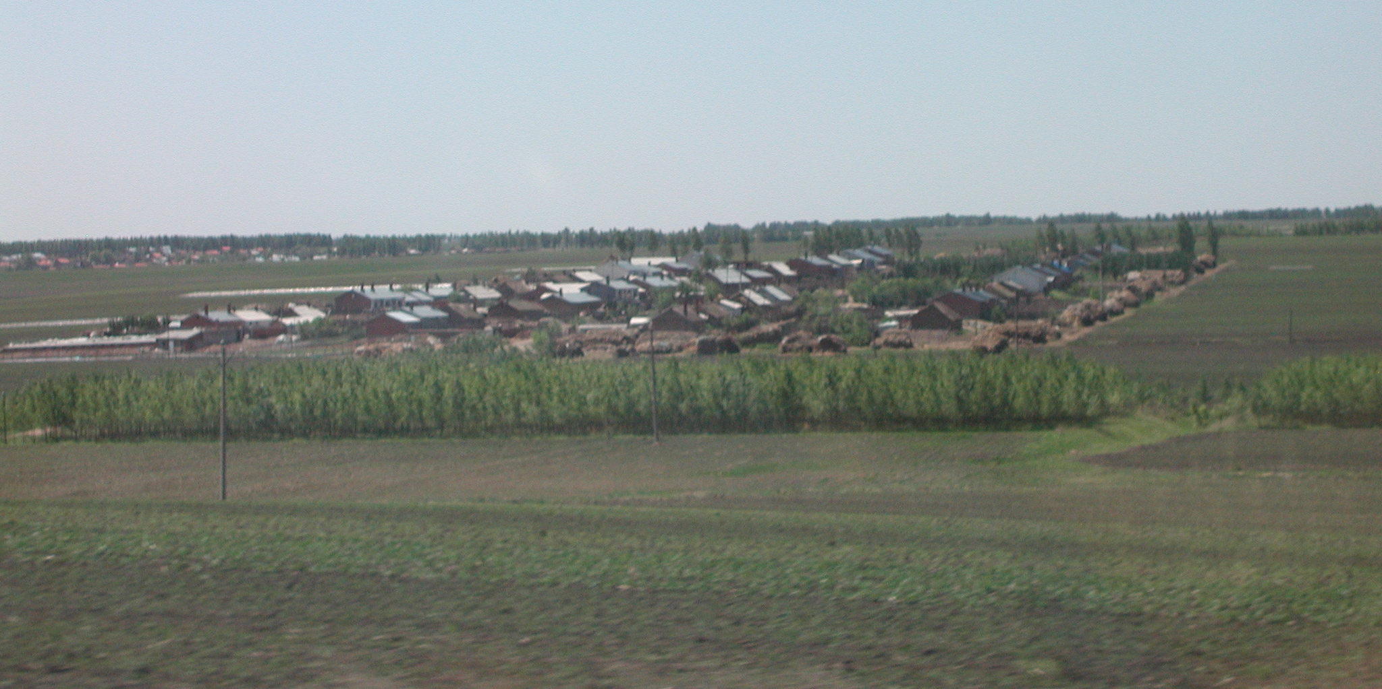

A farm village in Heilongjiang province surrounded by its agricultural land. This village is north of Harbin. Several rows of poplar trees has been planted between two fields. Surrounding the village are a large number of corn fodder stacks. The fodder is used to feed livestock in the absence of pastureland. Another village can be seen in the left background. Photo by Daryll E. Ray

Each house in the village had a backyard garden that was about forty or fifty feet wide (eyeball approximation—we didn’t get out and measure them) and half again as long. These gardens were fenced in using slab lumber from the local sawmill operations. Most of the gardens were well kept. From our car we could see winter onions and small fruit trees. The cool season crops were in one section of the garden. Small single row hooped plastic greenhouses were being used so that warm season plants could be seeded a couple of weeks early. Other warm season plants could be seen coming up in the open garden.
A couple of head of livestock were sometimes kept outside the back garden fence not far from the fodder stacks. We often also saw ducks and geese nearby. It would appear that these gardens provided the village residents with most of their fruits and vegetables. The animals could be used for household consumption or sold commercially.

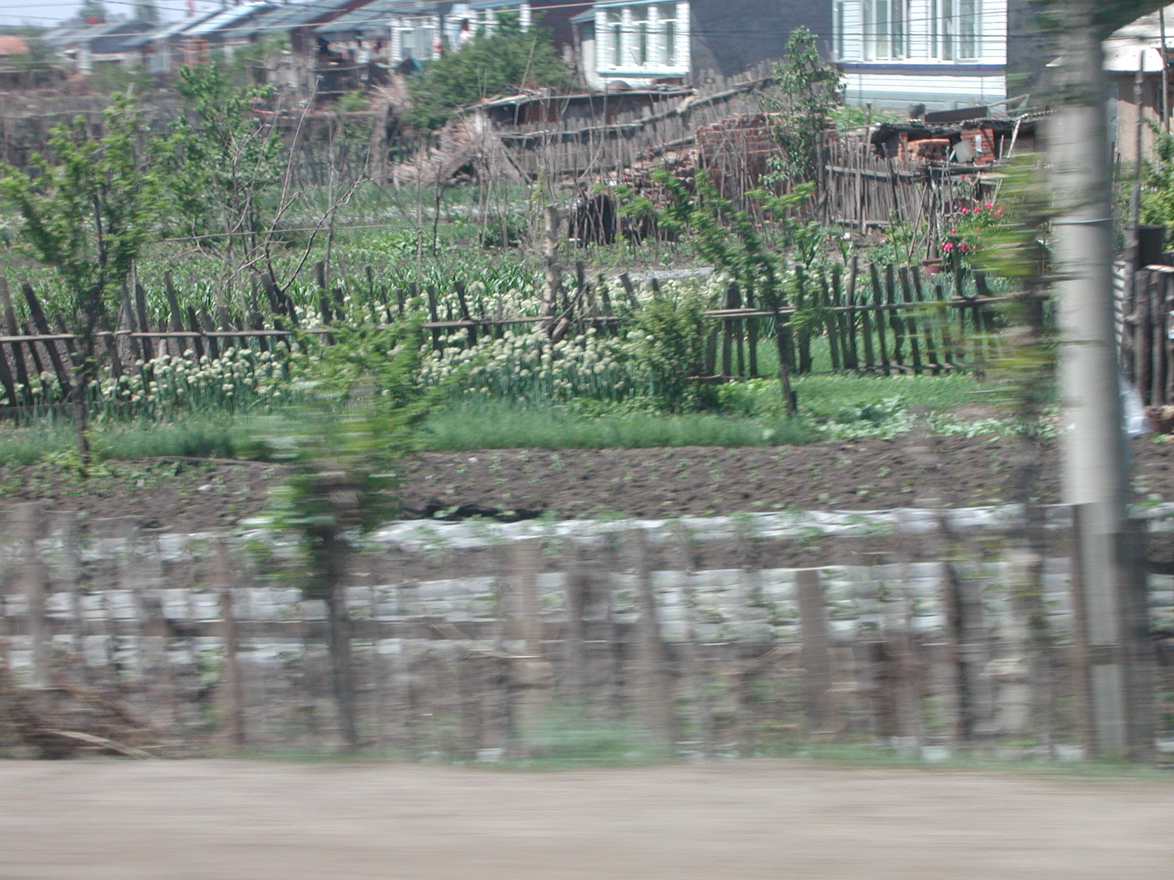

The typical village backyard garden in Heilongjiang province was about forty or fifty feet wide and half again as long surrounded by a slab wood fence. Several gardens can be seen in this photograph. Photo by Daryll E. Ray.

The poplar trees that were so plentiful in the North China Plain were also in evidence on our trip north from Harbin to Hailun.. Some of the poplar plantings appeared to be shelter belts to protect the villages from the strong North wind while others seemed to be rotational plantings for harvest. Along the roadside we saw a number of sawmills in operation serving as an additional source of income for area residents.
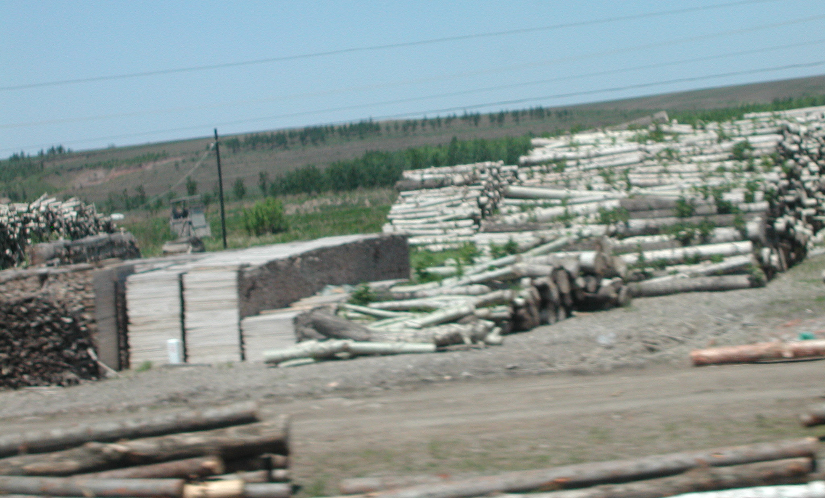

Freshly cut poplar logs are piled up next to several stacks of lumber. Small sawmills and lumber operations were a common sight along the road between Harbin and Hailun. Photo by Daryll E. Ray

While the fields were large and uniformly cultivated, they were not farmed by a single producer. Each farmer had the rights of a specific portion of the filed and was free to determine the crop that he/she wanted to plant. The crops included corn, soybeans, spring wheat, watermelons, potatoes, and flax. Farmers could be seen in the fields working their own rows. While cultivation by tractor or animals could eliminate weeds between the rows, farmers walked the rows hoeing the weeds between the plants.
In some ways, what we saw is a form or precision agriculture. With eight or more long rows that the farmers worked over and over, there is little doubt that they know the nature of every inch of their ground.
Some of the crops like watermelons were planted early under plastic row covers supported by regularly spaced hoops. At the time we were there, the farmers were in the process of splitting the plastic, removing the hoops and placing the plastic close around the plants as a weed barrier. It was clear that watermelon production was more labor intensive than corn and soybean, but, we were told, it is also more profitable.
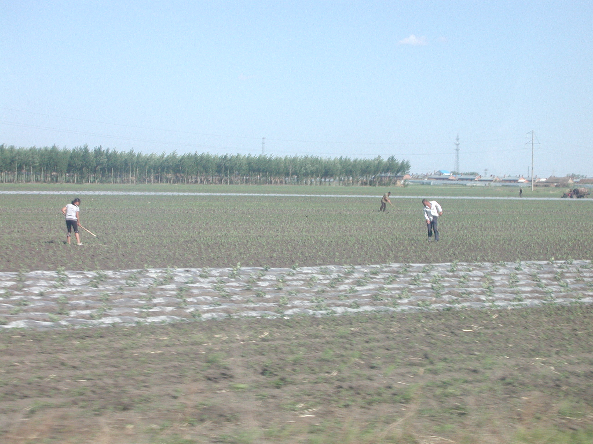

Farmers near Hailun are weeding their fields following mechanical cultivation. Each farmer is allocated a portion of a large field and can choose what he or she wants to plant. In the foreground are 8 rows of plastic mulch surrounding watermelon plants. Adjacent areas of the field were planted to corn and soybeans. In the background another set of rows with plastic mulch can be seen. Photo by Daryll E. Ray.

The intensive type of farming that we saw provided employment for a large number of people so that they did not need to leave the farm unless they were offered a better paying non-farm job.
Farming was not the only labor intensive employment sector. We saw people with brooms made of local materials sweeping the streets. Many of the streets and roadways were lined with flower beds that beautified the area and provided employment for the people who grew the plants, put them in the ground, and kept them weeded.
Looking out the window and talking to our host Dr. C. Li we learned quite a lot, even before we arrived at the Hailun Experiment Station.

Daryll E. Ray holds the Blasingame Chair of Excellence in Agricultural Policy, Institute of Agriculture, University of Tennessee, and is the Director of UT’s Agricultural Policy Analysis Center (APAC). (865) 974-7407; Fax: (865) 974-7298; dray@utk.edu; http://www.agpolicy.org. Daryll Ray’s column is written with the research and assistance of Harwood D. Schaffer, Research Associate with APAC.

Reproduction Permission Granted with:
1) Full attribution to Daryll E. Ray and the Agricultural Policy Analysis Center, University of Tennessee, Knoxville, TN;
2) An email sent to hdschaffer@utk.edu indicating how often you intend on running Dr. Ray’s column and your total circulation. Also, please send one copy of the first issue with Dr. Ray’s column in it to Harwood Schaffer, Agricultural Policy Analysis Center, 309 Morgan Hall, Knoxville, TN 37996-4519.

