China: Black soil, tractors and nematodes
After several hours of observing the agriculture of Heilongjiang province through the windows of the car in which we were riding, we arrived at the Hailun Experiment Station and had the chance to look at the agriculture of the area up close and personal. After lunch with experiment station staff, we wandered around the grounds on our own for a while.
It was at that point that Daryll noticed that the rich black soil looked very much like the soil he knew growing up on a farm in Iowa. It turns out that it is the same kind of soil (it is called Clarion Webster in the US and black soil in China) and researchers from the Hailun Station are collaborating with their counterparts at Iowa State University in some of their soil studies.
Like a couple of kids in a candy store we were intrigued by everything we saw—especially the tractor. As we walked into the field we could hear the putt-putt-putt of the engine as the driver made his way down between the crop rows, cultivating three rows at a time.

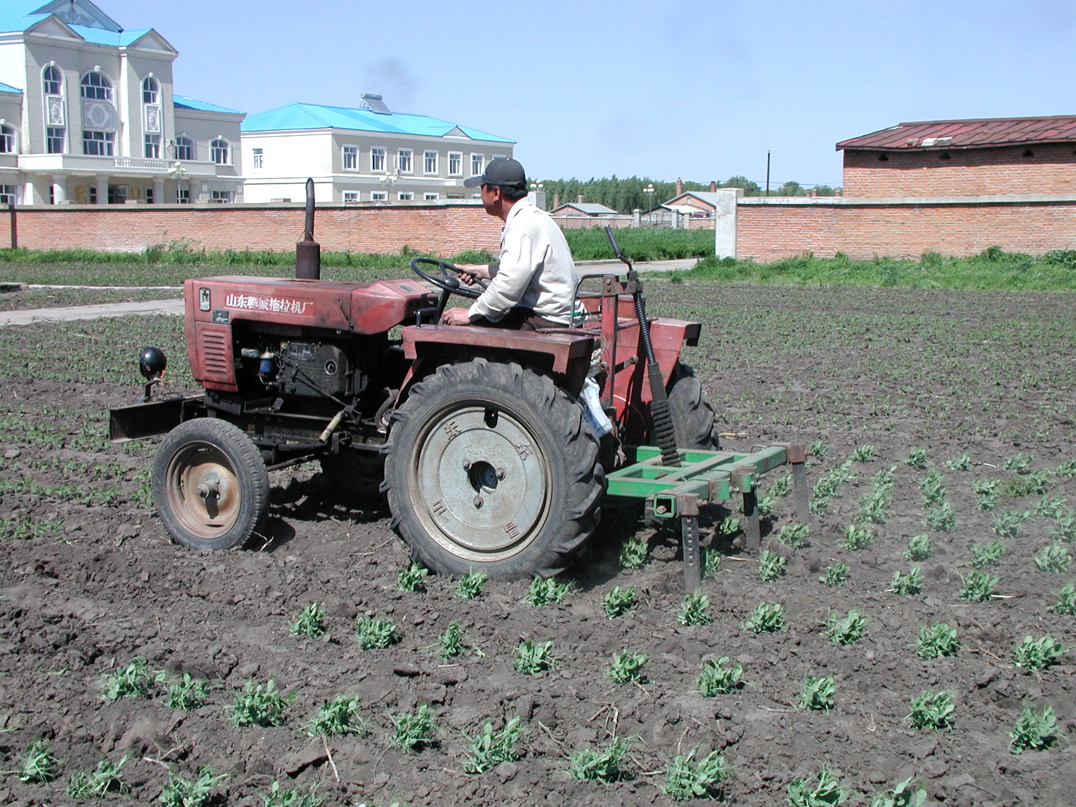

The typical tractor we saw in Heilongjiang was powered by a one cylinder diesel engine mounted on two I-beams. In early June, they were being used to cultivate between the crop rows. Photos by Daryll E. Ray.

At the end of the row the driver would take it out of gear and swivel around in his seat and hand crank the sweeps up out of the ground. He would then turn the tractor around and line up for the next three rows, hand cranking the cultivators back down—no hydraulics here—and take off across the field.
Unlike modern tractors in the US where the engine block is an integral element of the tractor frame, the frame of this tractor was two I-beams with a one cylinder diesel engine and some housing, a couple of fenders and a seat mounted on top and the wheels mounted underneath. The tillage equipment was mounted at the back. It is simple, functional, and repairable. The power was transmitted from the engine to the back wheels using V-belts and a pulley on each end—an updated version of the pulley and flat belts used on stationary and steam traction engines a century ago.
After wandering around for a while, we were joined by Chunjie Li, Assistant Professor with the Northeast Institute of Geography and Agroecology (NEIGAE), Chinese Academy of Sciences (CAS). She introduced us to the work being done at the Hailun Station and explained some of the experiments that were being conducted under the direction of Professor, Yanli Xu.
The Hailun Experiment Station in Heilongjiang is located in the heart of the black soil area of Northeast China, 120 road miles north of Harbin and 150 miles (as the crow flies—the road mileage is longer) from the Amur River and the Russian Far East. The station is a part of the NEIGAE, CAS established the station to help meet the agricultural development needs of Northeast China, integrating research and demonstration for agroecological practices and new technology. The goals of the research include providing the theoretical foundation, technological support and policy-making basis for water and land resource use, agro-environmental conservation and the development of sustainable agriculture in Northeast China.
With these goals in mind, researchers at the Hailun Experiment Station are conducting a number of long-term experiments to help them understand and provide guidance to farmers that will enable them to improve the black soil that is predominant in this region.
The black soil is formed in cool temperate zones with meadow-grassland vegetation. After years of farming, the soil had become degraded and so the experiment station studied ways to bring about the ecological restoration of these soils. One of the experiments begun in 1985 looks at natural restoration with native grasses and no other management as a means of restoring degenerated soil. Results from this plot are compared to a control plot that is kept barren.

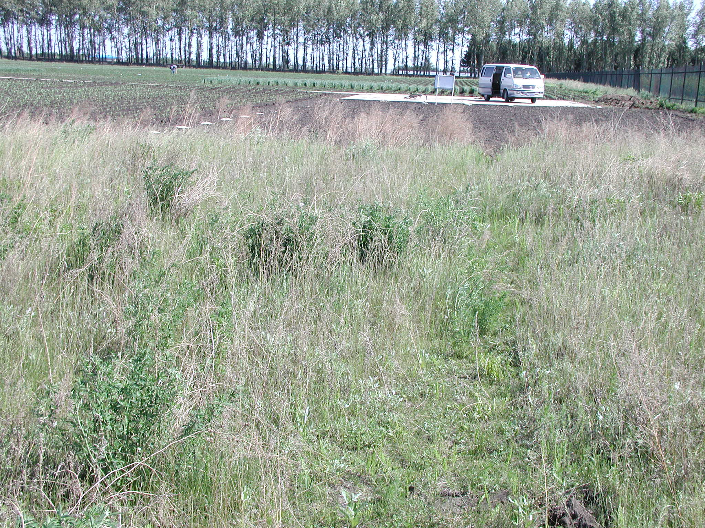

The grassy plot in the foreground looks at using natural grasses with no other management as one of the ways to restore degenerated black soil. Results from this plot are compared to those from the plot behind it where the soil is kept bare, no planting and no grass.

A companion experiment also begun in 1985 examines four development modes of agriculture in China—culture-fallow agriculture, organic (recycled organic matter) agriculture, petroleum agriculture, and a combination of organic (recycled organic matter) and petroleum agriculture—and their effect on the restoration of black soils.
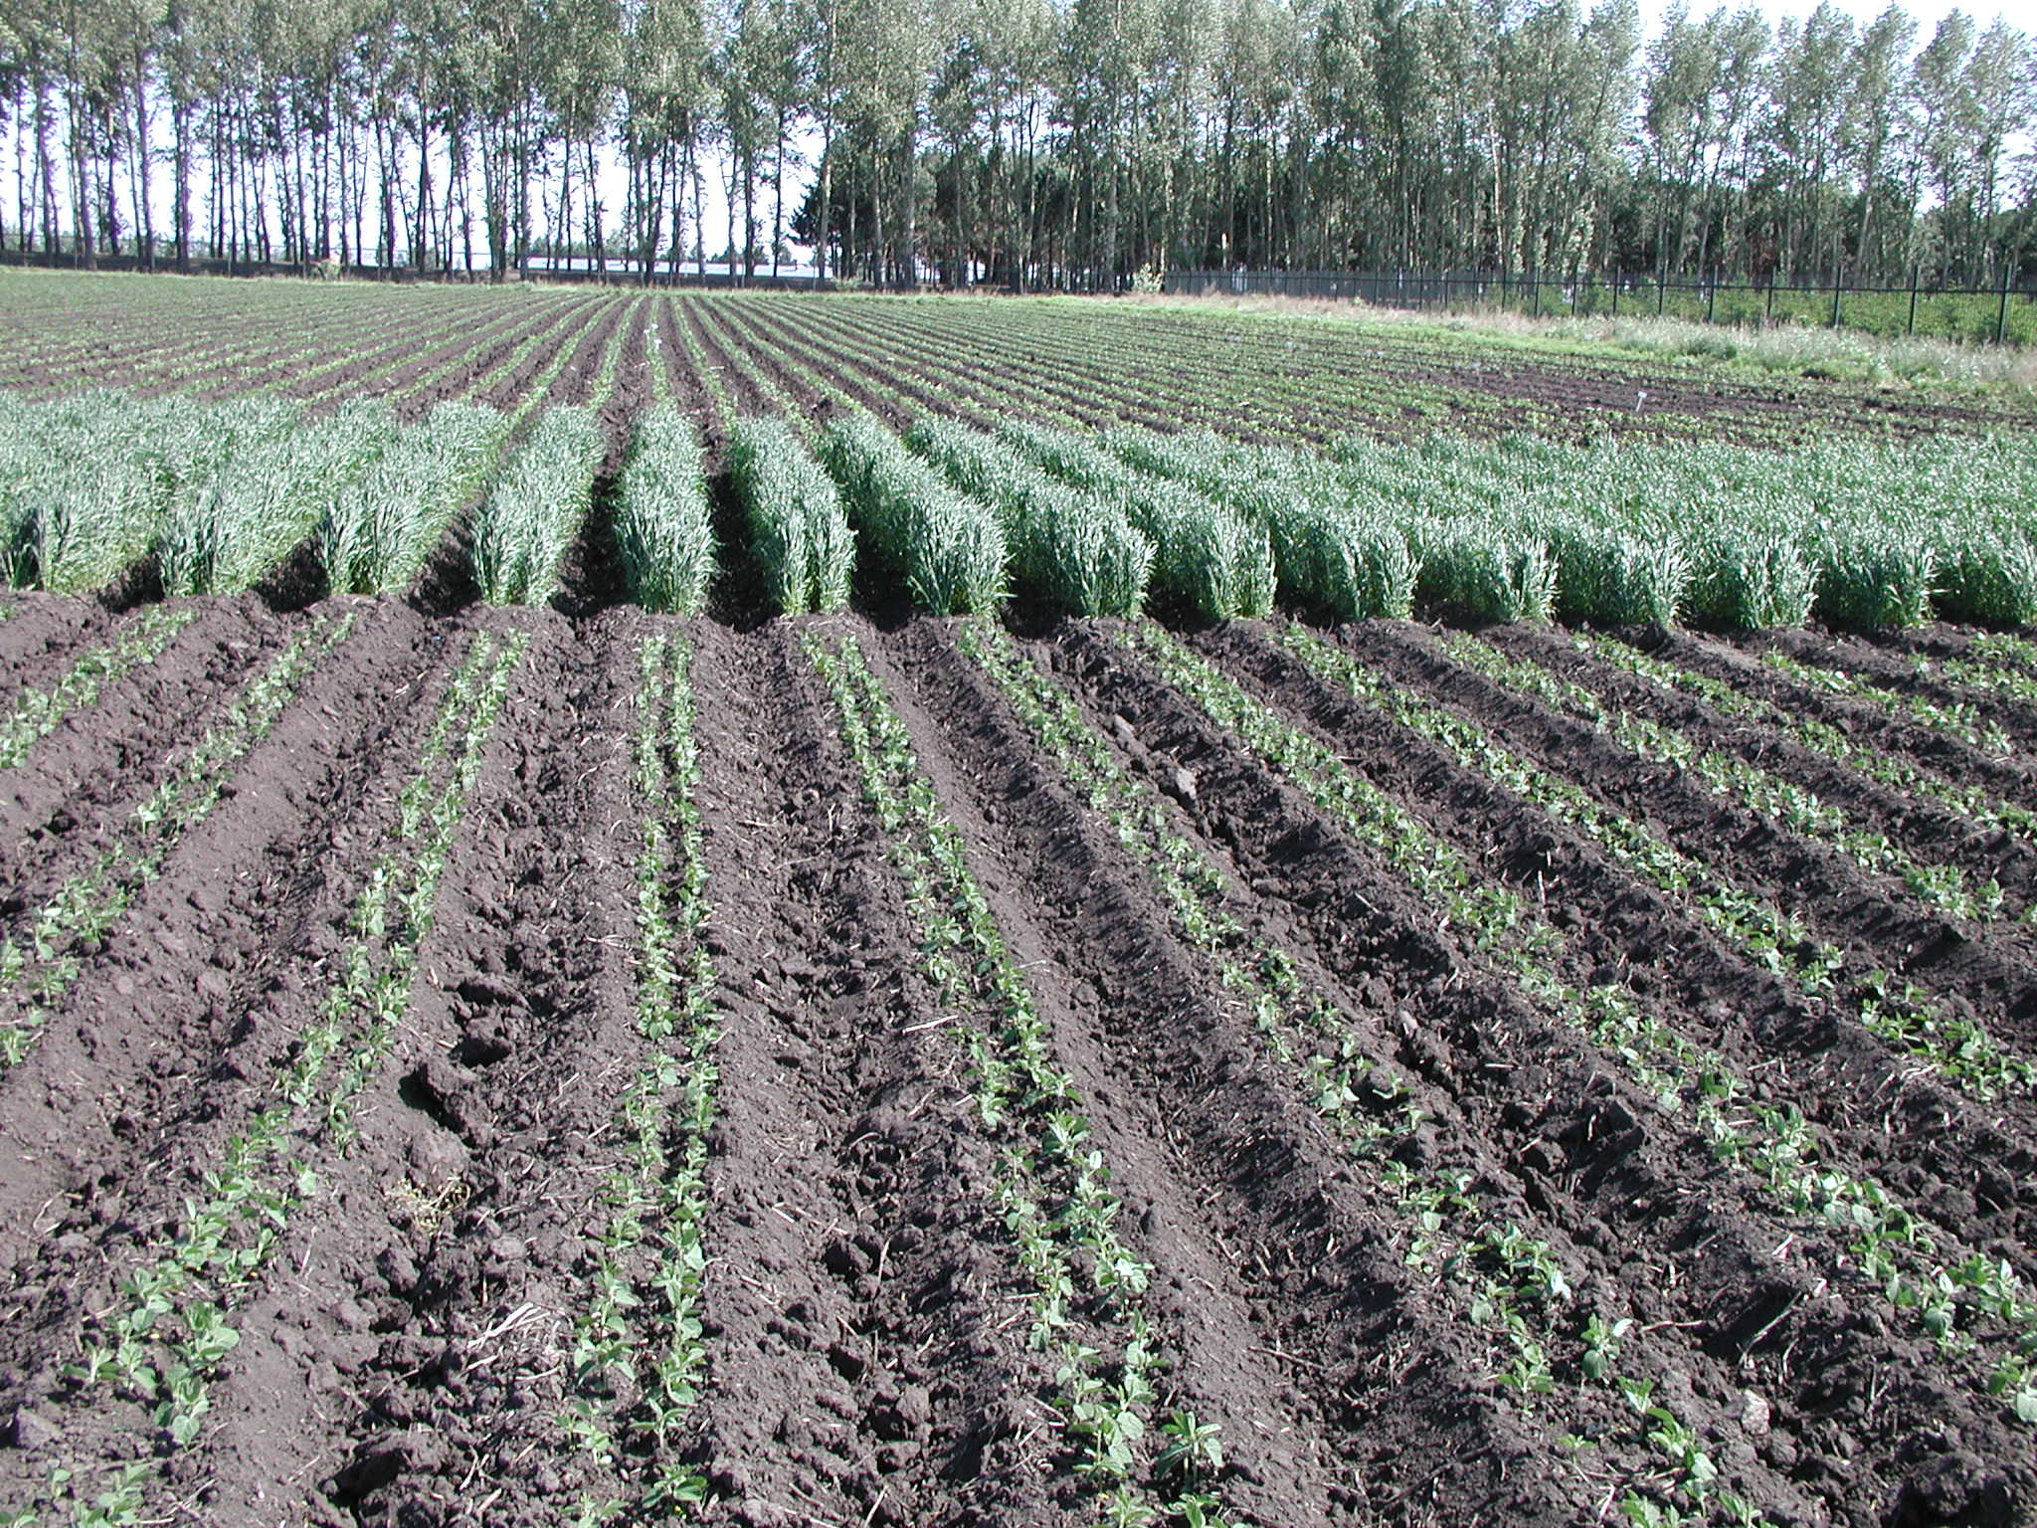

The fields at the Hailun Experiment Station were divided up into plots that were 11 ridge rows wide and 10 meters long. In the foreground emerging soybean plants can be seen, while spring wheat is in the midground. Both soybeans and wheat are planted two rows to a ridge, while corn is planted in a single row on each ridge.

In 1990 a long-term site-specific experiment on the nature of the increase and decline of organic matter in farmland black soil was begun. This study is important because black soil is one China’s soils with a high organic content and it was observed that the after being reclaimed, organic matter in the soil declined year by year. The purpose of the study was to try to identify how the organic content of the soil could be improved. Five replicated treatments using no fertilizer, fertilizer alone and various combinations and rates of fertilizer and straw in a wheat-corn rotation are being examined.
Because soybeans are more profitable than other crops, many farmers in Northeast China choose the continuous cropping of soybeans on the ground they work, despite some yield loss due to nematode infestation. In 1990 the station began the examination of the impact of continuous cropping comparing nine rotations, replicated three times in the field.
One of the interesting results of this ongoing experiment was that after a period of time, the continuous cropped soybeans began to experience some yield recovery. A close examination of the soil showed that in the presence of high soybean cyst nematode numbers, a parasitic fungus had appeared in the field. The parasitic fungus infected the nematodes, reducing their numbers and the impact they had on yield. This fungus is now under further study by Professor Xu and her team of scientists.
A number of other experiments were also being conducted by researchers at the Hailun Experiment Station. All of the research we saw was publicly funded with the results disseminated to farmers in the region.
Given the intensity and the quality of the research we saw in progress, is it not surprising that China’s crop yields have steadily improved.

Daryll E. Ray holds the Blasingame Chair of Excellence in Agricultural Policy, Institute of Agriculture, University of Tennessee, and is the Director of UT’s Agricultural Policy Analysis Center (APAC). (865) 974-7407; Fax: (865) 974-7298; dray@utk.edu; http://www.agpolicy.org. Daryll Ray’s column is written with the research and assistance of Harwood D. Schaffer, Research Associate with APAC.

Reproduction Permission Granted with:
1) Full attribution to Daryll E. Ray and the Agricultural Policy Analysis Center, University of Tennessee, Knoxville, TN;
2) An email sent to hdschaffer@utk.edu indicating how often you intend on running Dr. Ray’s column and your total circulation. Also, please send one copy of the first issue with Dr. Ray’s column in it to Harwood Schaffer, Agricultural Policy Analysis Center, 309 Morgan Hall, Knoxville, TN 37996-4519.

