A 1,700 acre farming operation in China and Saturday-night like activity in town
Not content with looking at experimentation plots and observing farming from the back seat of an automobile, while we were at the Hailun Experiment Station we wanted to get out and visit some farms and observe farming first hand. Our hosts at the station, Assistant Professor Chunjie Li and the Superintendent of the Hailun station were gracious enough to take us to a village 5 or 6 kilometers from the station.
The village is called Victory and consists of several unpaved streets with houses lining each side and household gardens in the back yard. While the houses are all about the same size, the residents of some houses have put on metal roofs while others have thatched roofs.
Poplars are growing on the windward side of town like shelter belts protecting the village from the harsh winds. Fodder stacks along with household livestock also surround the village.
We went to the village hall to meet with the main official who seems to be a cross between a mayor and a business agent. Several other village leaders also joined us as we asked them questions.
They told us that 1,798 people are a part of the village with 1,173 of them workers. 450 people work outside the village and an additional 150 are mobile workers who return in the winter season. Many of these mobile workers farm across the Amur River in the Russian Far East.
The number of farmers in the village is 365, so like in the US, off-farm income is important. They told us that the average annual income in the village was $500 per person. That sounds low, and it is. But when one takes into account that villagers are able to grow most of their own food (a major expense in developing nations), it is not as low as it seems. Visiting the village we did not see what we would describe as poverty, despite the low per capita income.
The village has 700 hectares (1,730 acres) of ground that is distributed among the farmers. The land of people who leave farming and take a job in town goes back into the pool to be redistributed. We did not ask enough questions to fully understand the land allocation process.
We were told that each farmer decides what is grown on his/her land. As a result adjacent rows in a large field could be planted to different crops. The common crops grown in the area included corn, soybeans, sugar beets, spring wheat, watermelon, potatoes, and flax. With most of the work being done by hand, the change in crops did not seem to create much of a problem. The fields look somewhat like those in the sandhills of West-Central Kansas that are strip cropped to reduce the effects of wind erosion.
The high-protein corn that is grown for human consumption yields 8 tonnes per hectare (127 bushel per acre). Ten years ago the yield was 5.5 tonnes per hectare (88 bushels per acre). The corn that is grown for animal feed yields up to 12 tonnes per hectare (191 bushels per acre).
Soybean yields for the village are now 2.5 tonnes per hectare (37 bushels per acre) compared to 1.5 tonnes per hectare (22 bushels per acre) ten years ago.
We asked to go out into the fields and see them first hand. The field they took us to had about 50 people hoeing down weeds. We asked what the crop was and were told that it was sugar beets. The company buying the sugar beets did not allow the farmers to use herbicides as a part of their cropping practices. The only pre-emergence weed control was the original tilling. And now that the sugar beets had emerged, the farmers were hoeing down the weeds that covered the field.
It appears that sugar beet production is a village-level enterprise in which everyone participated in the production and tillage. The sugar beet processing plant allocates a fixed number of acres to the village for sugar beet production.
Sugar beet production is the village’s most profitable crop, yielding a net profit of $70 per mu (about 1/15th of a hectare) or about $425 per acre.

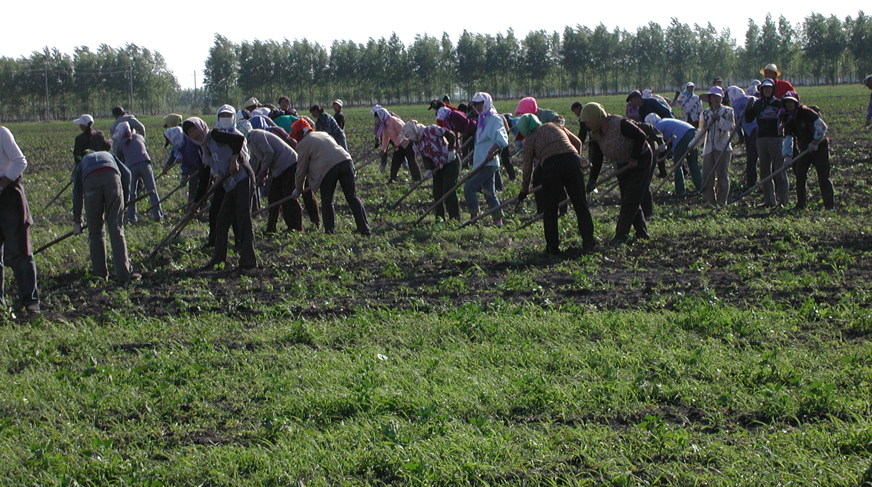

Victory village farmers making the first pass of hoeing a field after the sugar beet tops have emerged. Hand work is necessary because the plant does not want chemicals used on the fields. Sugar beets are the village’s most profitable crop with net income of $425 per acre. Photos by Daryll E. Ray.

On the way back to the experiment station we saw greenhouses with cornstalks covering the sides and the tops. “What are they growing there?” we asked. “Mushrooms,” we were told.
Looking at the agricultural system as a whole, it appears to us that Chinese farmers have adopted a farming strategy that minimizes their risk in the case of unforeseen circumstances. They have a wide variety of field crops, a wide variety of garden crops, a number of different animal species, poplar trees to sell as lumber and off-farm income from some community members. Despite high energy prices, low crop prices, or reduced yields of one or more crops, they will still have something to sell, and plenty of food to eat.

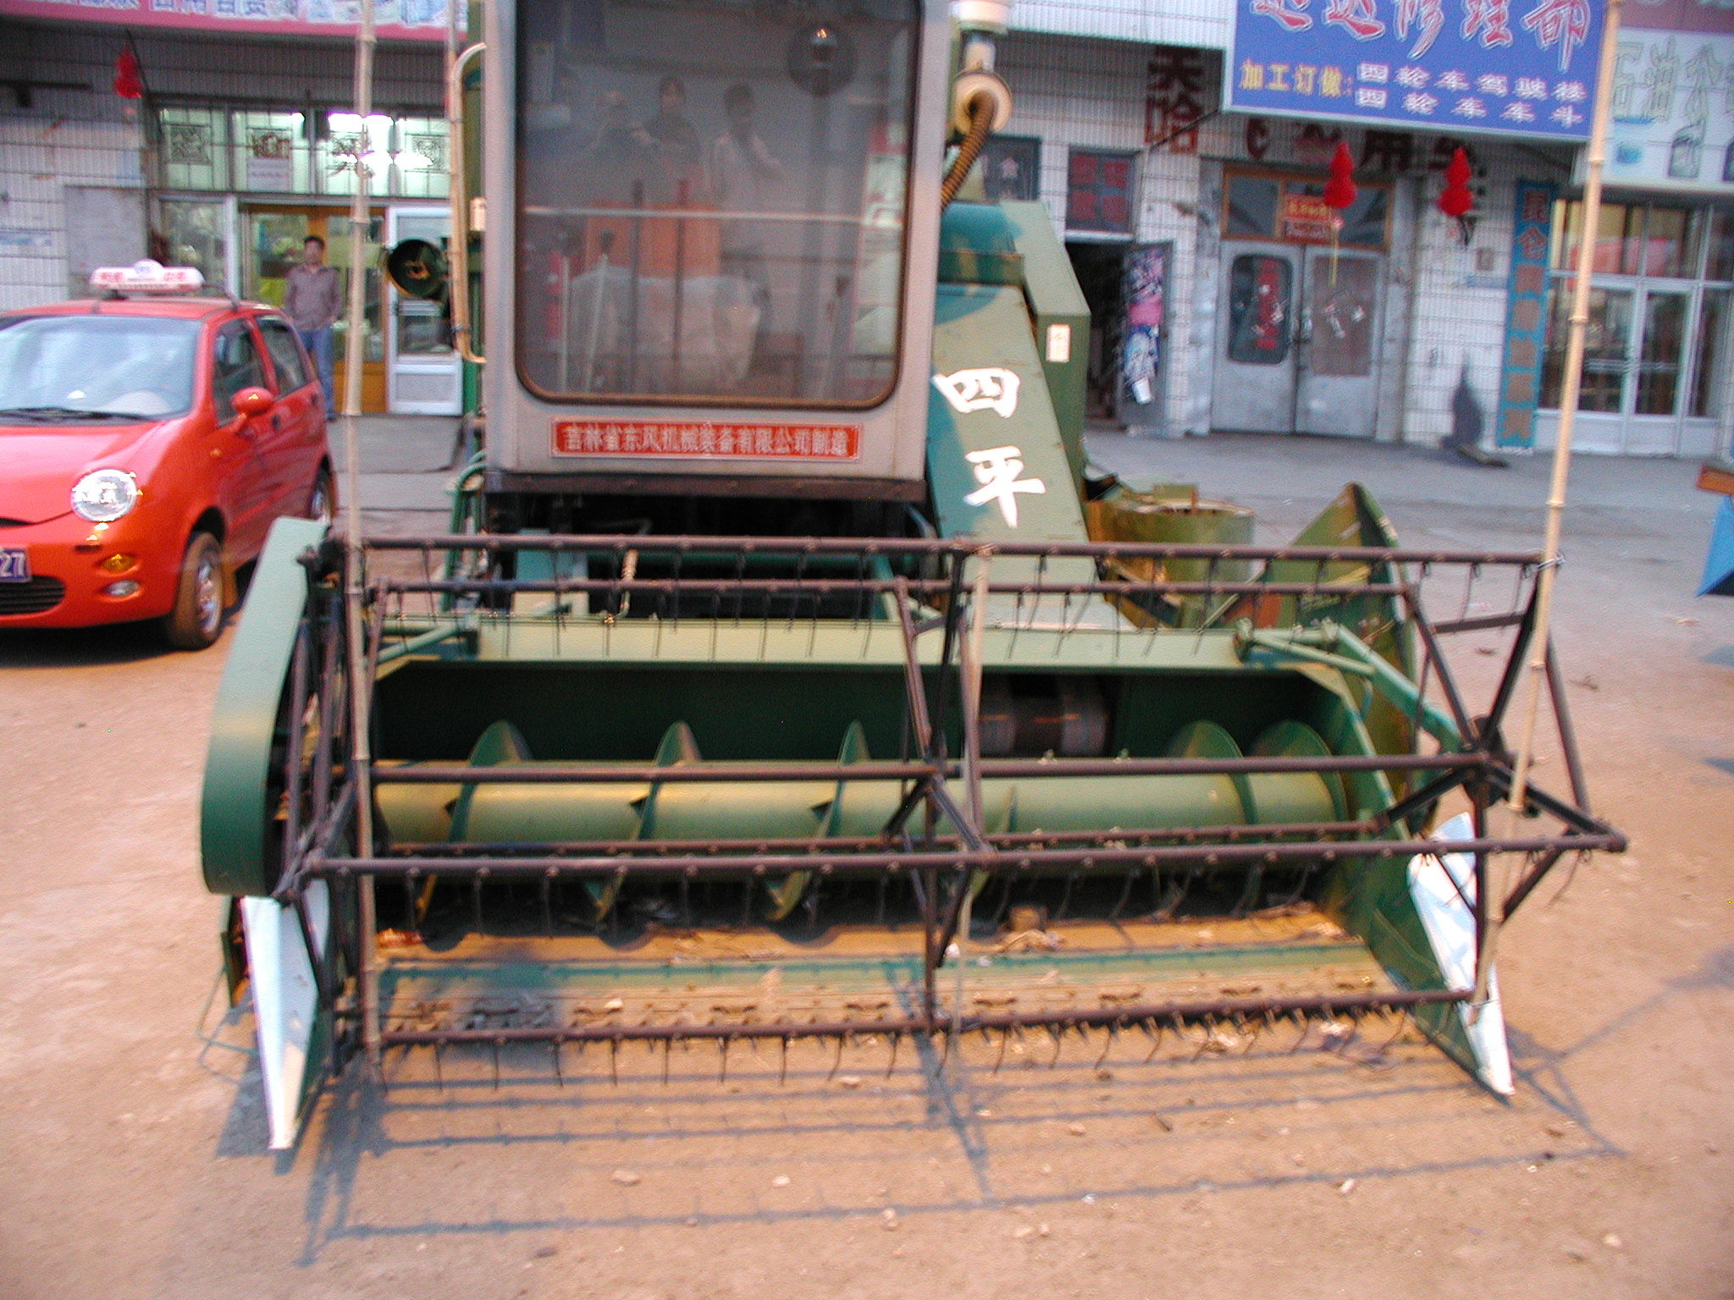

A small combine that was for sale on machinery row in Hailun, Heilongjiang, China. On machinery row we also saw a number of regionally produced Chinese brand tractors and a few John Deere combines.

After supper at the Hailun Experiment Station, we decided to walk into the neighboring country town of Hailun (population 108,000) along with our host and a group of graduate researchers. The first kilometer or so was on a rough dirt road lined with houses and a variety of shops and repair facilities. Once we got into the town proper, the road was paved and the main street was very wide.
The two of us were like kids in a candy story. Both sides of the wide street were lined all kinds of farm equipment on the wide sidewalks that abutted against 4 to 5 story buildings with shops on the first floors and apartments above that. There were tractors, combines, corn pickers, and shellers. Most of them were small by US standards. Most were local brands but we did some green John Deere machines.
The one cylinder diesels that we had seen in the fields were in abundance. Newer design two cylinder versions were available as well. While walking on the street we stopped to look at a one cylinder diesel tractor on which the owner had attached a grinding wheel for sharpening hand tools. The tractor was parked on the sidewalk. As we gathered around to look at it and figure out how the grinding wheel was powered, the owner came out of a nearby shop, reached behind the seat, grabbed the starter crank, stuffed it under his coat and went back inside as he gave us a suspicious glance.
The Hailun street on a Tuesday night was a beehive of activity. Couples, hand in hand, were out for a walk. Kids were playing on the sidewalk and in the street. Vendors had restaurants set up on the sidewalk offering Hailun’s famous grilled meat on a thin stick. Everyone was busy talking, eating, buying and selling, and simply enjoying a comfortable summer’s evening.
The activity reminded us of what Saturday night was like back when we were growing up in small towns in middle America. Okay, so we are no longer young. It was still exciting
Not to take anything away from Bill and Ted but that evening walk into Hailun was one of many portions of Daryll and Harwood’s [Most] Excellent Adventure.
And yes, while we were in China we did climb the Great Wall. It took us three and a half hours to reach the eighth tower at the Badaling section.
We took the cable car down.

Daryll E. Ray holds the Blasingame Chair of Excellence in Agricultural Policy, Institute of Agriculture, University of Tennessee, and is the Director of UT’s Agricultural Policy Analysis Center (APAC). (865) 974-7407; Fax: (865) 974-7298; dray@utk.edu; http://www.agpolicy.org. Daryll Ray’s column is written with the research and assistance of Harwood D. Schaffer, Research Associate with APAC.

Reproduction Permission Granted with:
1) Full attribution to Daryll E. Ray and the Agricultural Policy Analysis Center, University of Tennessee, Knoxville, TN;
2) An email sent to hdschaffer@utk.edu indicating how often you intend on running Dr. Ray’s column and your total circulation. Also, please send one copy of the first issue with Dr. Ray’s column in it to Harwood Schaffer, Agricultural Policy Analysis Center, 309 Morgan Hall, Knoxville, TN 37996-4519.

