Self-reliance is the goal of Farmer Group 5 in Guédé Chantier, Senegal
In a conversation Harwood had with the Deputy Mayor of Guédé Chantier, Senegal, Amadou Sy, the Deputy Mayor talked about a recent meeting he had with the presidents of the various farmers’ groups. In that meeting he learned that Farmer Group 5 had CFA 11.5 million (approximately US$ 24,000) in a savings account while the other groups had nothing approaching that amount.
A couple of days later, Harwood had the opportunity to sit down and talk with Abu Samba Sow, the President of Farmer Group 5. He explained that the current farmer groups were established in 1993 when the dike was constructed around the community, covering up some fields thus necessitating a reassignment of fields to members of the community. The community was divided into 2 sections with each deciding on their own organizational pattern.
Section 1 established 5 groups and Group 5 elected Sow as President. As he says, “In my vision, I structured the organization of the group into three levels: the General Assembly, the Executive Board, and the Advisory Board. The most important group is the General Assembly. I was the President from 1993 to 2002 and then wanted to retire. So I called a meeting of the General Assembly and told them I wanted to rest. That created a big stir in Group 5 and the General Assembly said, ‘No, you cannot resign! What we will do is elect you as President and you choose the bureau members.’ I tried to say no, no, no, but finally what you cannot resist, you must accept.
“As for the management of my group, I really had to do it, though it was beyond my strength. To help me, I appointed bureau members and these appointments were validated by the General Assembly. The General Assembly asked the people holding office to exercise a strict discipline. The Executive Board and the 5 sub-groups I established, each led by a chief, had a precise set of tasks they were to achieve.
“The other farmer groups in Guédé Chantier are dependent upon the bank, but this is not true for Group 5. After a couple of years, group 5 decided that they couldn’t go without a savings account so they started one. The group expects each hectare to contribute to the financial security of the group. To accomplish their goal of financial security the group decided on their own set of rules.
“There are two categories of fines. Someone who does not work or misbehaves is fined for misbehavior. If the rules are broken, the leader determines the amount of the damage according to the seriousness from CFA 5,000 to CFA 50,000. These fines are put into the savings account. The group has community fields of 15 Ha and the profit from these are also put into the savings account. Part of our rules are that each campaign must pay its own debt. If you grow rice, you pay from that campaign not tomatoes.
“Every time we harvest, when the last person finishes their harvest, the deadline for payment is the next Monday. People are required to pay their debt with either cash or the crop immediately following harvest. Those who do not pay on time are fined. The sanction is different if they use the crop to feed their family or if they use it to invest in another plot of land outside the group, they are charged a percentage of the debt.
“Then everything we get from sanctions and fines goes into the account when we finish. We then harvest the weeds and sell them to the herders. This also goes into the savings account.
“Then we have boxes to carry tomatoes for weighing and the charges for the boxes are put into the account. All we have in common goes into the savings account.
“At the end of the harvest, we evaluate everything that did not work from a technical or financial perspective.

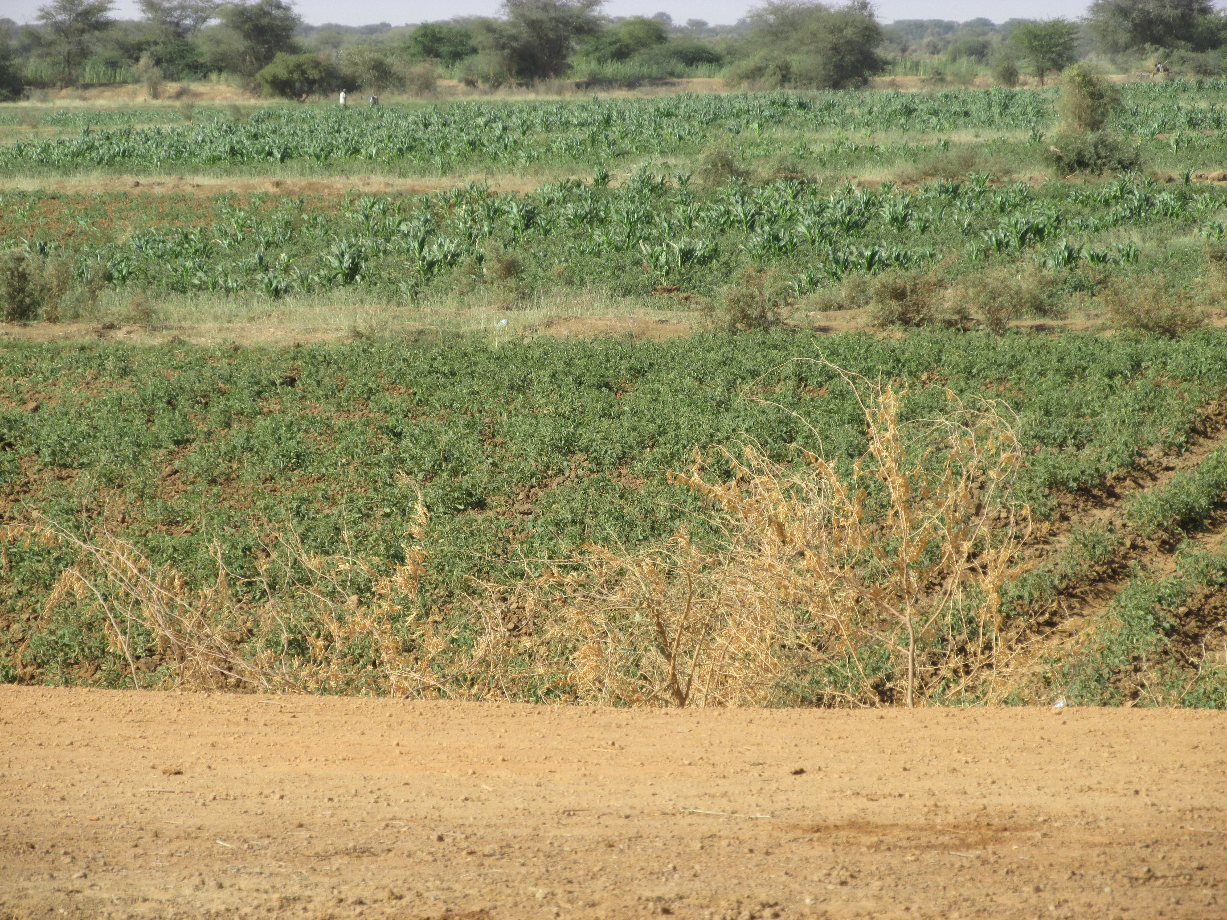

During the cool season (January – April), farmers in Guédé Chantier, Senegal plant tomatoes, maize, cabbage, onions, and okra. The field in the foreground is tomatoes. The fields in the center and back of the picture contain maize inter-planted with various vegetable crops. Many of the trees in the background are mango trees which were in bloom during Harwood’s February visit. They will bear fruit later in the year.

“Last Saturday (February 8, 2014) we had a General Assembly and I invited a director of the bank who spent the day with us. During our last evaluation we realized that we had CFA 11.5 million. For the new crop we have a loan from the bank for approximately CFA 25 million and CFA 8 million from the group bank account. 28 percent of the cost of putting in the new crop comes from the savings of the Group 5. The interest we will pay back to the bank is CFA 1.5 million. We realized that if this interest rate was going back into our savings account, we could soon fund our own loans. Our objective is to fully fund our farming activities.
“The transparency of the leadership group is very important. We have three campaigns a year: dry, rain, cool. We meet at length three times a year as the General Assembly before sowing. The leadership visits each field visit three times during each campaign. The Executive Board calculates the dues for each person in the group and that money is put into the savings account. The General assembly meets at least 9 times a year plus the annual meeting and the Executive Board schedules a meeting whenever necessary.”
One of the goals that the community leaders and Harwood set for themselves is to find ways for the other farmer groups to learn the self-management tools that Group 5 has developed. In that way the farmers can exercise greater control over their financial and agricultural destiny. If the groups have adequate financial reserves, then they can finance crops other than those the bank is willing to finance—rice, tomatoes, and onions—and find additional ways to improve the financial and nutritional stability of Guédé Chantier.

Daryll E. Ray holds the Blasingame Chair of Excellence in Agricultural Policy, Institute of Agriculture, University of Tennessee, and is the Director of UT’s Agricultural Policy Analysis Center (APAC). Harwood D. Schaffer is a Research Assistant Professor at APAC. (865) 974-7407; Fax: (865) 974-7298; dray@utk.edu and hdschaffer@utk.edu; http://www.agpolicy.org.

Reproduction Permission Granted with:
1) Full attribution to Daryll E. Ray and Harwood D. Schaffer, Agricultural Policy Analysis Center, University of Tennessee, Knoxville, TN;
2) An email sent to hdschaffer@utk.edu indicating how often you intend on running the column and your total circulation. Also, please send one copy of the first issue with the column in it to Harwood Schaffer, Agricultural Policy Analysis Center, 309 Morgan Hall, Knoxville, TN 37996-4519.

